**FUNDAMENTALS OF DATA ANALYTICS WITH TABLEAU**

**PROJECT TITLE**

**iREVOLUTION A DATA DRIVEN EXPLORATION OF APPLE’S iPHONE IMPACT IN INDIA**

**NAAN MUDHALVAN PROJECT ID:**

**NM2023TMID27723**

**TEAM MEMBERS:**

**1. R.URMEILA [TEAM LEADER]**

**2. M.PRAGATHEESWARI**

**3. M.SELVARANI**

**4. C.SARANYA**

**5. G.RANJITHA**

.



**PG AND RESEARCH DEPARTMENT OF PHYSICS**

**RAJA DORAISINGAM GOVERNMENT ARTS**

**COLLEGE**

**SIVAGANGAI-630561**

**INTRODUCTION**

***1.1 OVERVIEW***

Series of smart phones produced by apple INC, compining mobile telephone, digital camera, music player, and personal computing technologies.The iphone made mobile web browsing useful for the first time. Soon came a flood of apps, which remored the need to open a web browser at all, and opened a hole new world for the user.Apple INC has emerged as a prominent player among the top smart phones makers.

***1.2 PURPOSE***

It was originally invented to call or text someone, now it is used to get on the internet, text, facetime, and call. The iphone is a smartphone made by apple that combine a computer, ipad, digital camera and cellular phone into one device with a touch screen.

**PROBLEM DEFINITION & DESIGN THINKING**

***2.1 EMPATHY MAP***

First we make a empathy map for a group idea. To create a empathy we go to mural website and logic with emai, account and search the templates that you wanted to create.

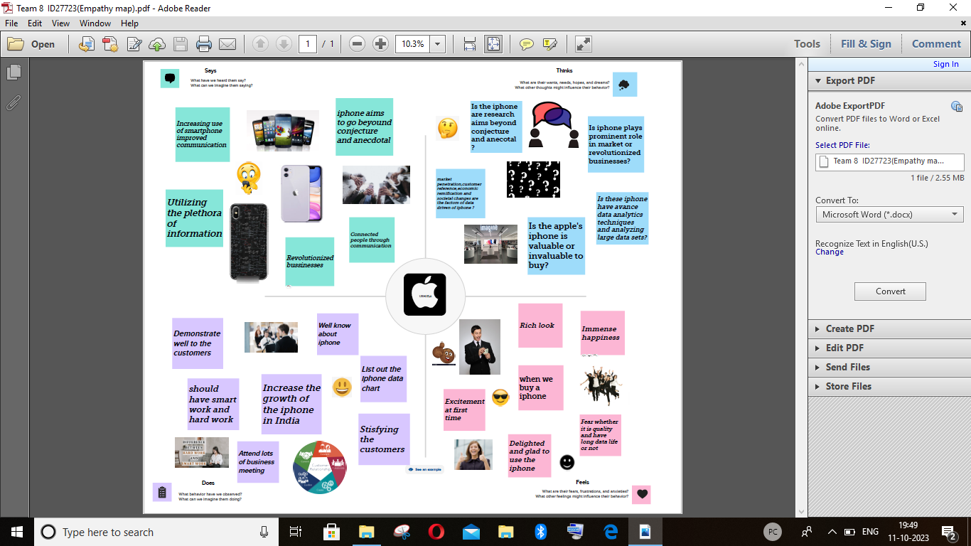

**2.2 IDEATION & BRAINSTORMING MAP**

Make a brainstorm map with mural website in brainstorm we discussed the define problem and understanding the problem . First we have defined what are the problems and types in the quention box. That it a group idea and is written in the box person1 ,person2, person3, person4, now four person give different idea for problem.Take best three idea and type in the last box.

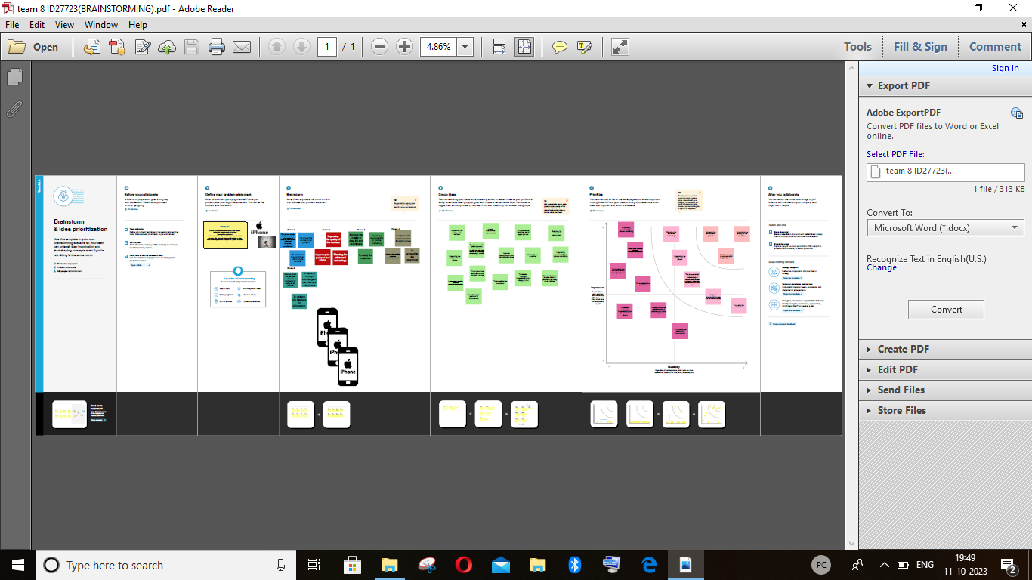

**RESULT**

Before opening the tableau desktop we had download the dataset for our project.After download the dataset we open the tableau desktop.After opening the option selected connect to data , select the more option and select the dataset.

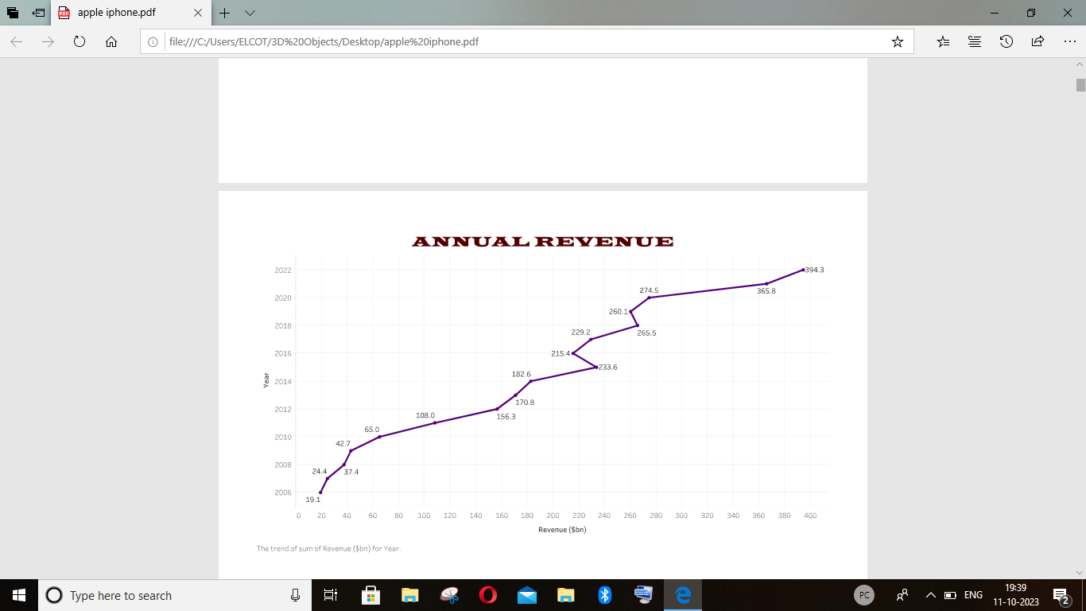

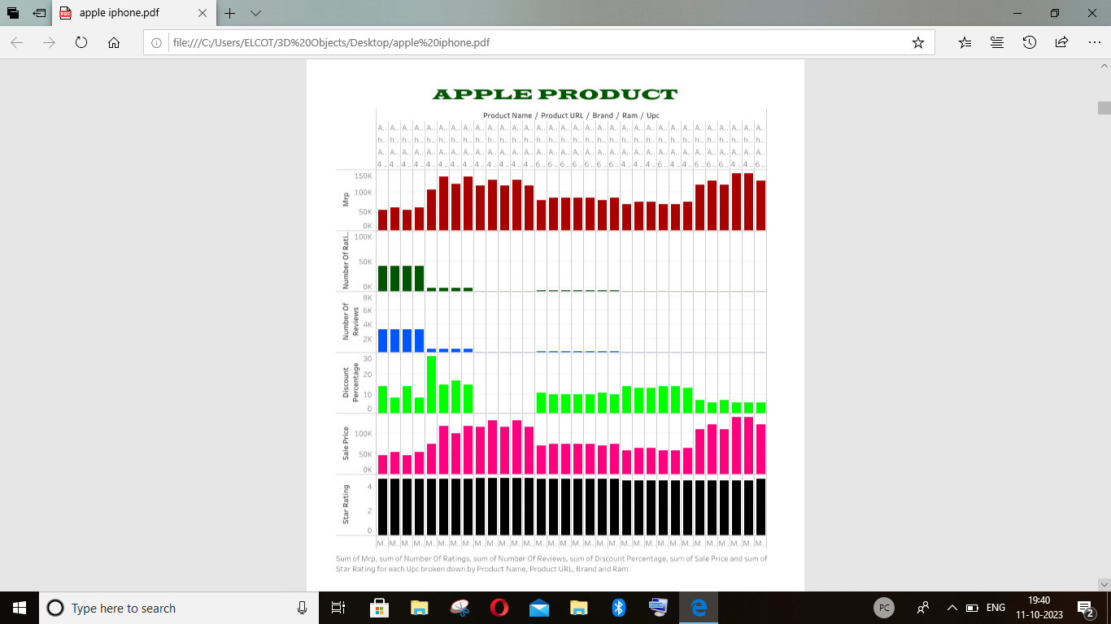

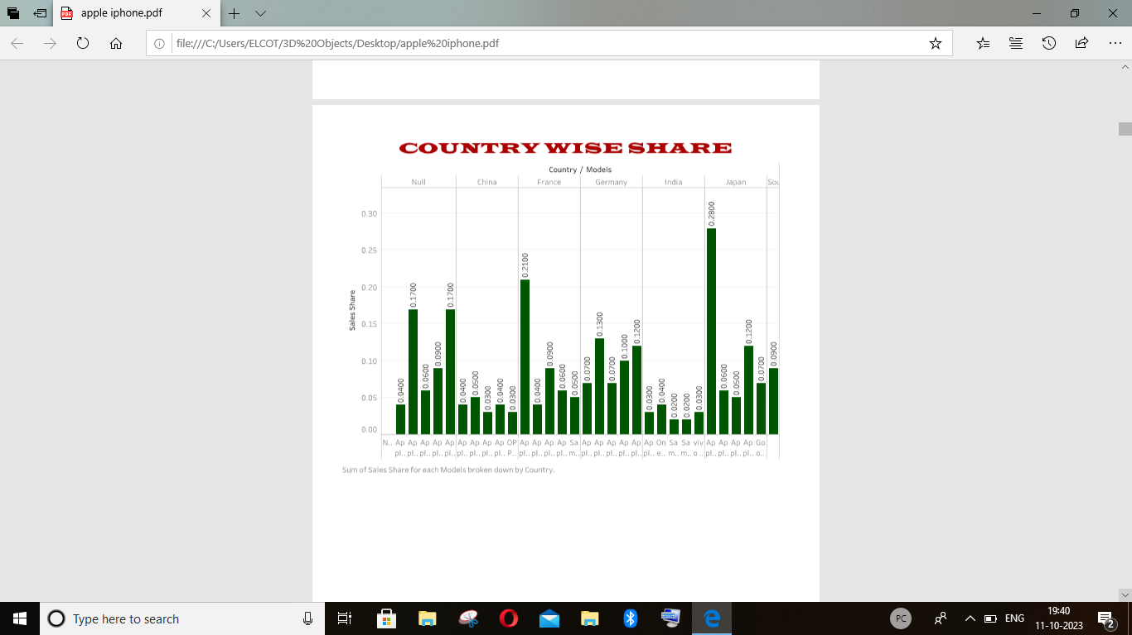

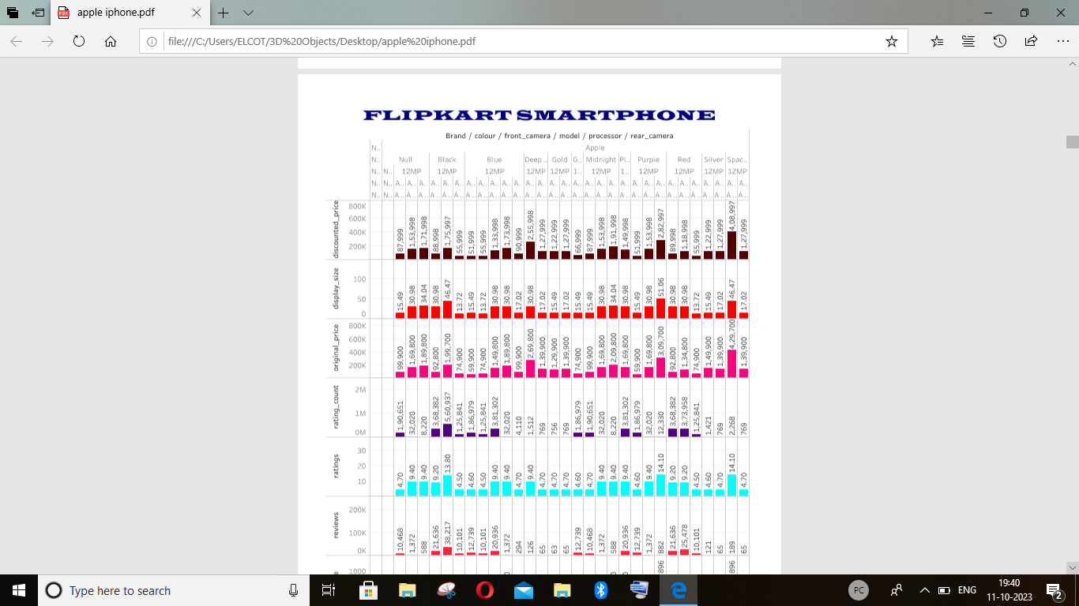

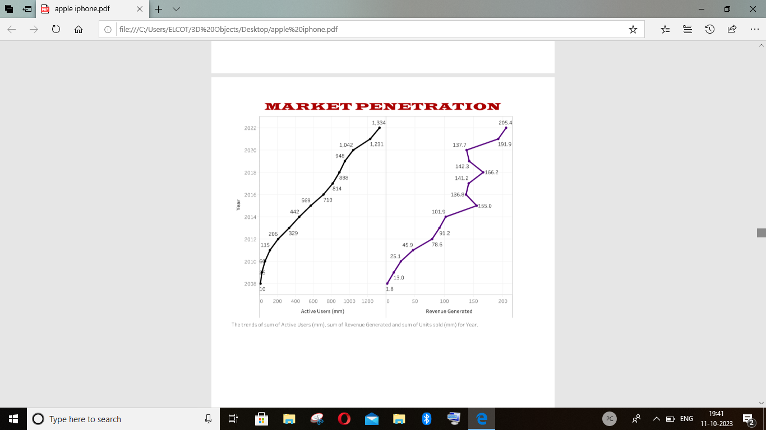

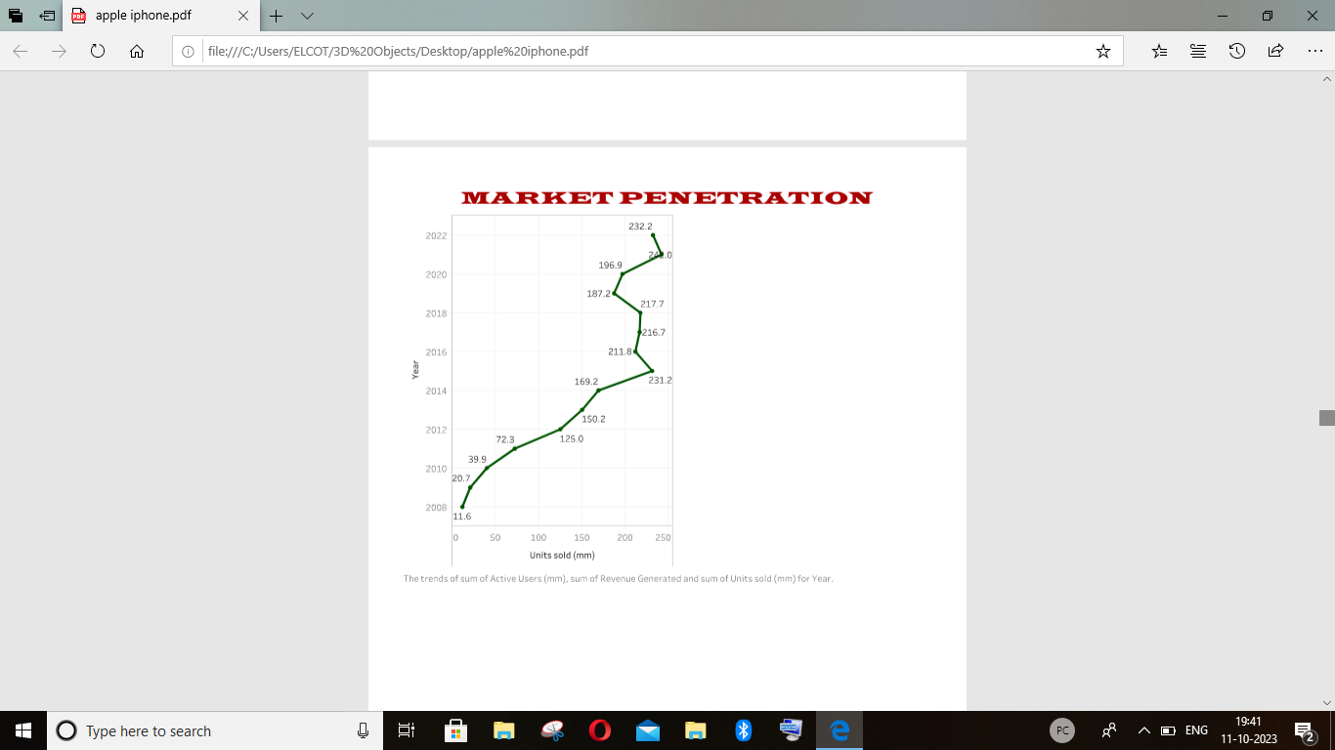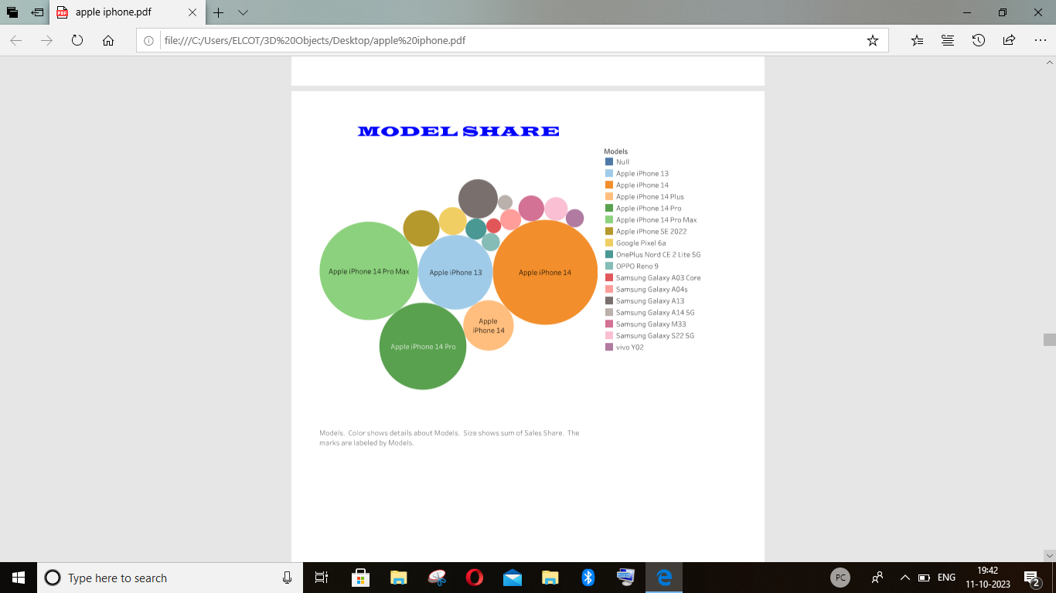

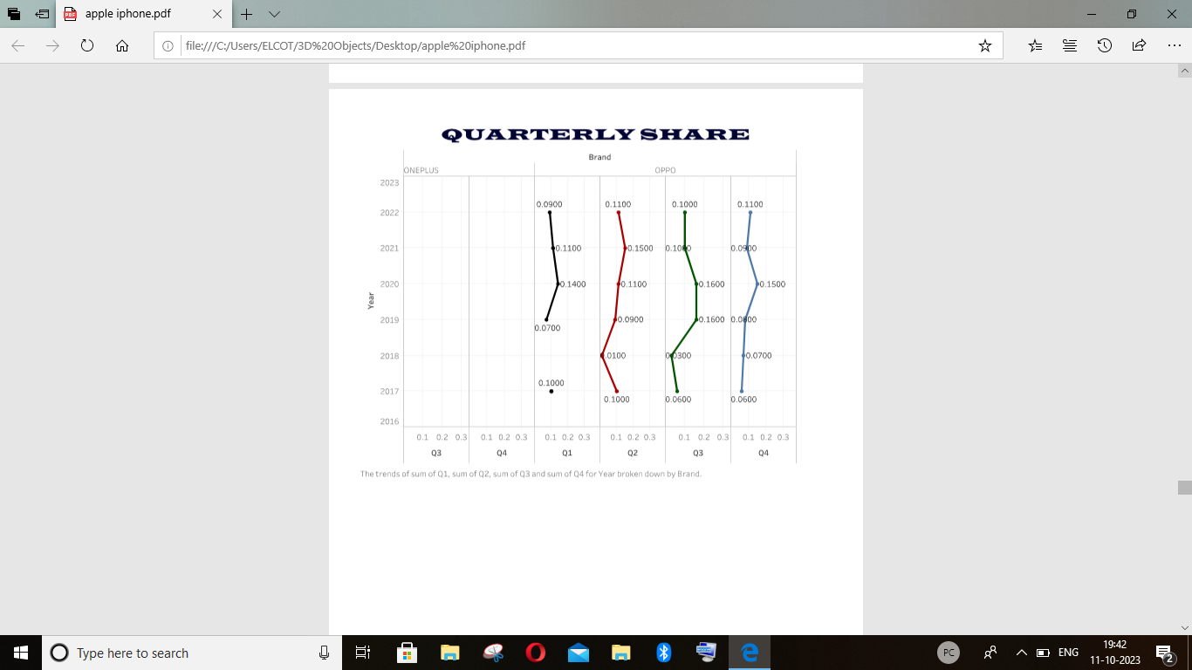

After finishing the analysis data , add a dashboard.

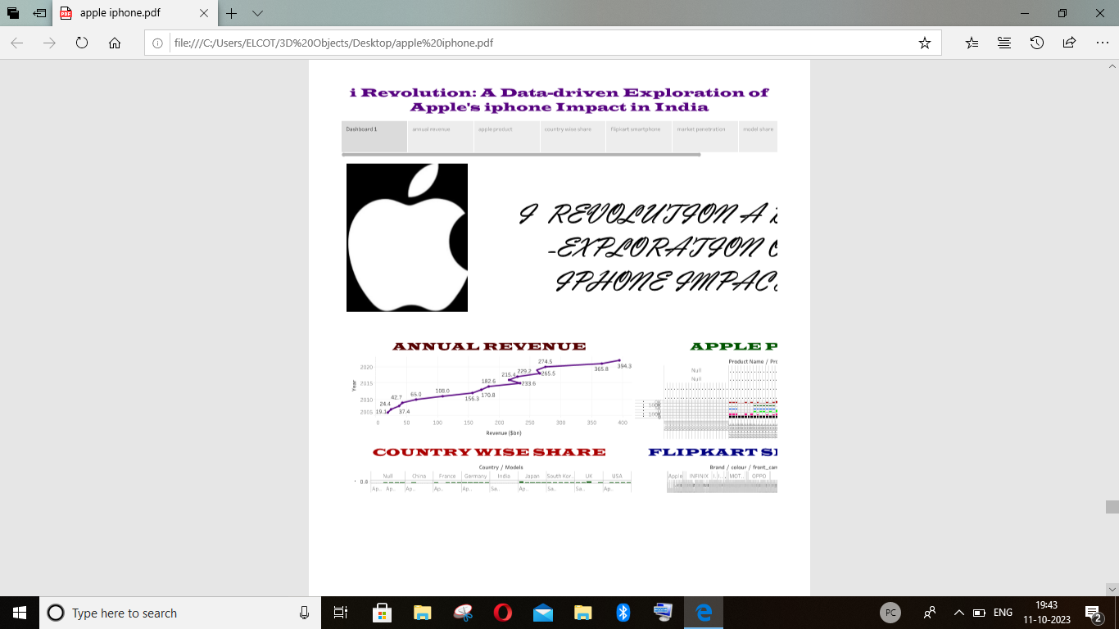

We create a story in the tableau desktop.

Sign in to the tableau account.

Publish the workbook in the tableau cloud

Upload the project in the github.

**ADVANTAGES:**

* MOBILE- FRIENDLY
* EXTENSIVE CUSTOMER RESOURCES,
* EXCELLENT MOBILE SUPPORT
* EASY TO UPGRADE
* EASY OF USE
* LOW COST

**DISADVANTAGES:**

* The trial period limits only for about 15 days.

**APPLICATIONS:**

It is very easy to apply the data analysis and visualization to create a view based on the fields already used to selected in data pane.

**CONCLUTION:**

Innovation and technological advancemencts have keep the iphone and apple ahead of its competators in this tight market With the iphone being so popular and in high demand, estimated are suspected.

**FUTURE SCOPE:**

A person with knowledge of tableau can get many roles DATA ANALYSIS ,business analyst , and tableau consultant .Further in business intelligence , one can get roles like business intelligence analyst , business intelligence developer, and business intelligence manager, all of which are highly paying roles.